**Day 1 Lab Assignments**

1. Design the following sample home page using the following main layout for Desktop (and make sure that it’s completely **responsive**):

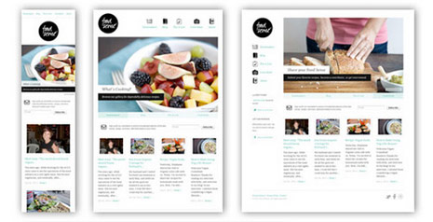



1. Use grid layout with your CV page design, and make sure that it’s completely responsive (use viewport meta tag):
   1. Change the middle content in the given image to be full-page width.
   2. Use 16 columns layout.
   3. Set box-sizing property.
   4. Use Viewport units with the font size for text in the header (Name), and max-width with the image.
   5. Use float property or flexbox.
   6. Use **flex** instead of float (**Bonus**).
   7. What are the differences between custom grid layout, and CSS display: grid?
      1. Use CSS grid, instead of Custom grid (<https://www.w3schools.com/css/css_grid.asp>).
   8. Change the header image in tablet and mobile view (Use picture tag).

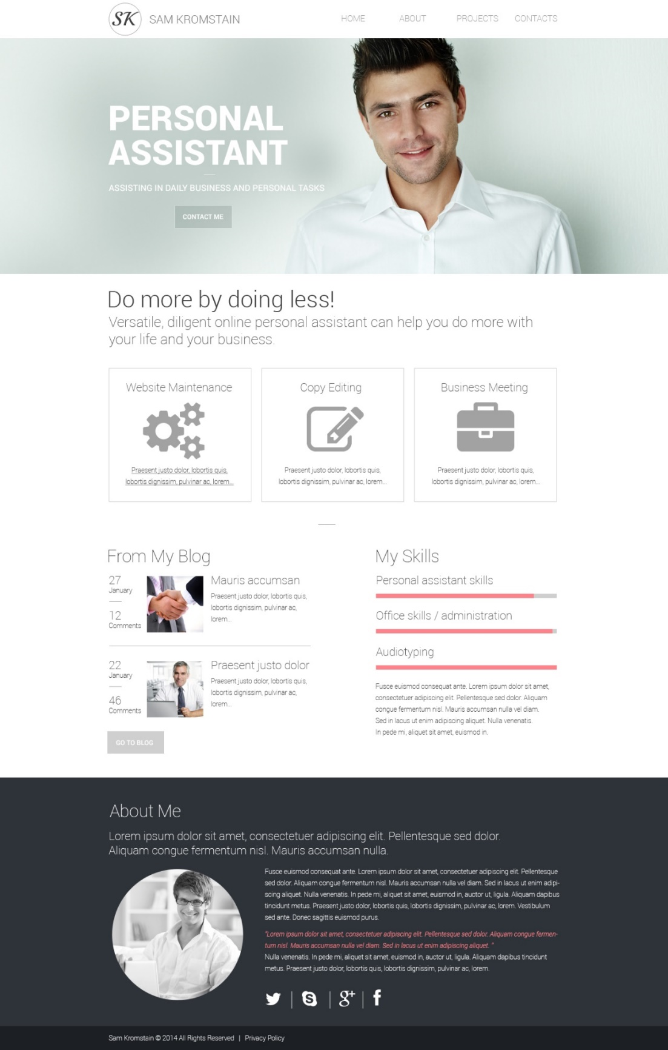

**Bonus Assignments:**

1. What are the differences between custom grid layout, and CSS display: grid?

<https://www.w3schools.com/css/css_grid.asp>

1. Use column-based design to design the following template:

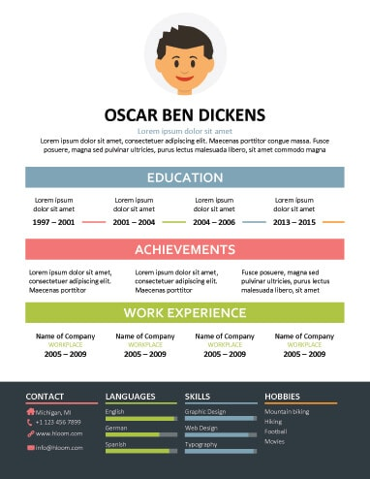

1. Redo the same design using “Mostly fluid” and “Off-canvas” RWD pattern, and try different RWD patterns generally.
2. What’re CSS frameworks? Search for different frameworks and list their features, and differences between them?
3. What’re CSS pre-processor? Search for different frameworks and list their features, and differences between them.
4. What’s BEM? Explain using demo.
5. What’s material design? Explain using demo.

**<Thank>YOU </Thank>**